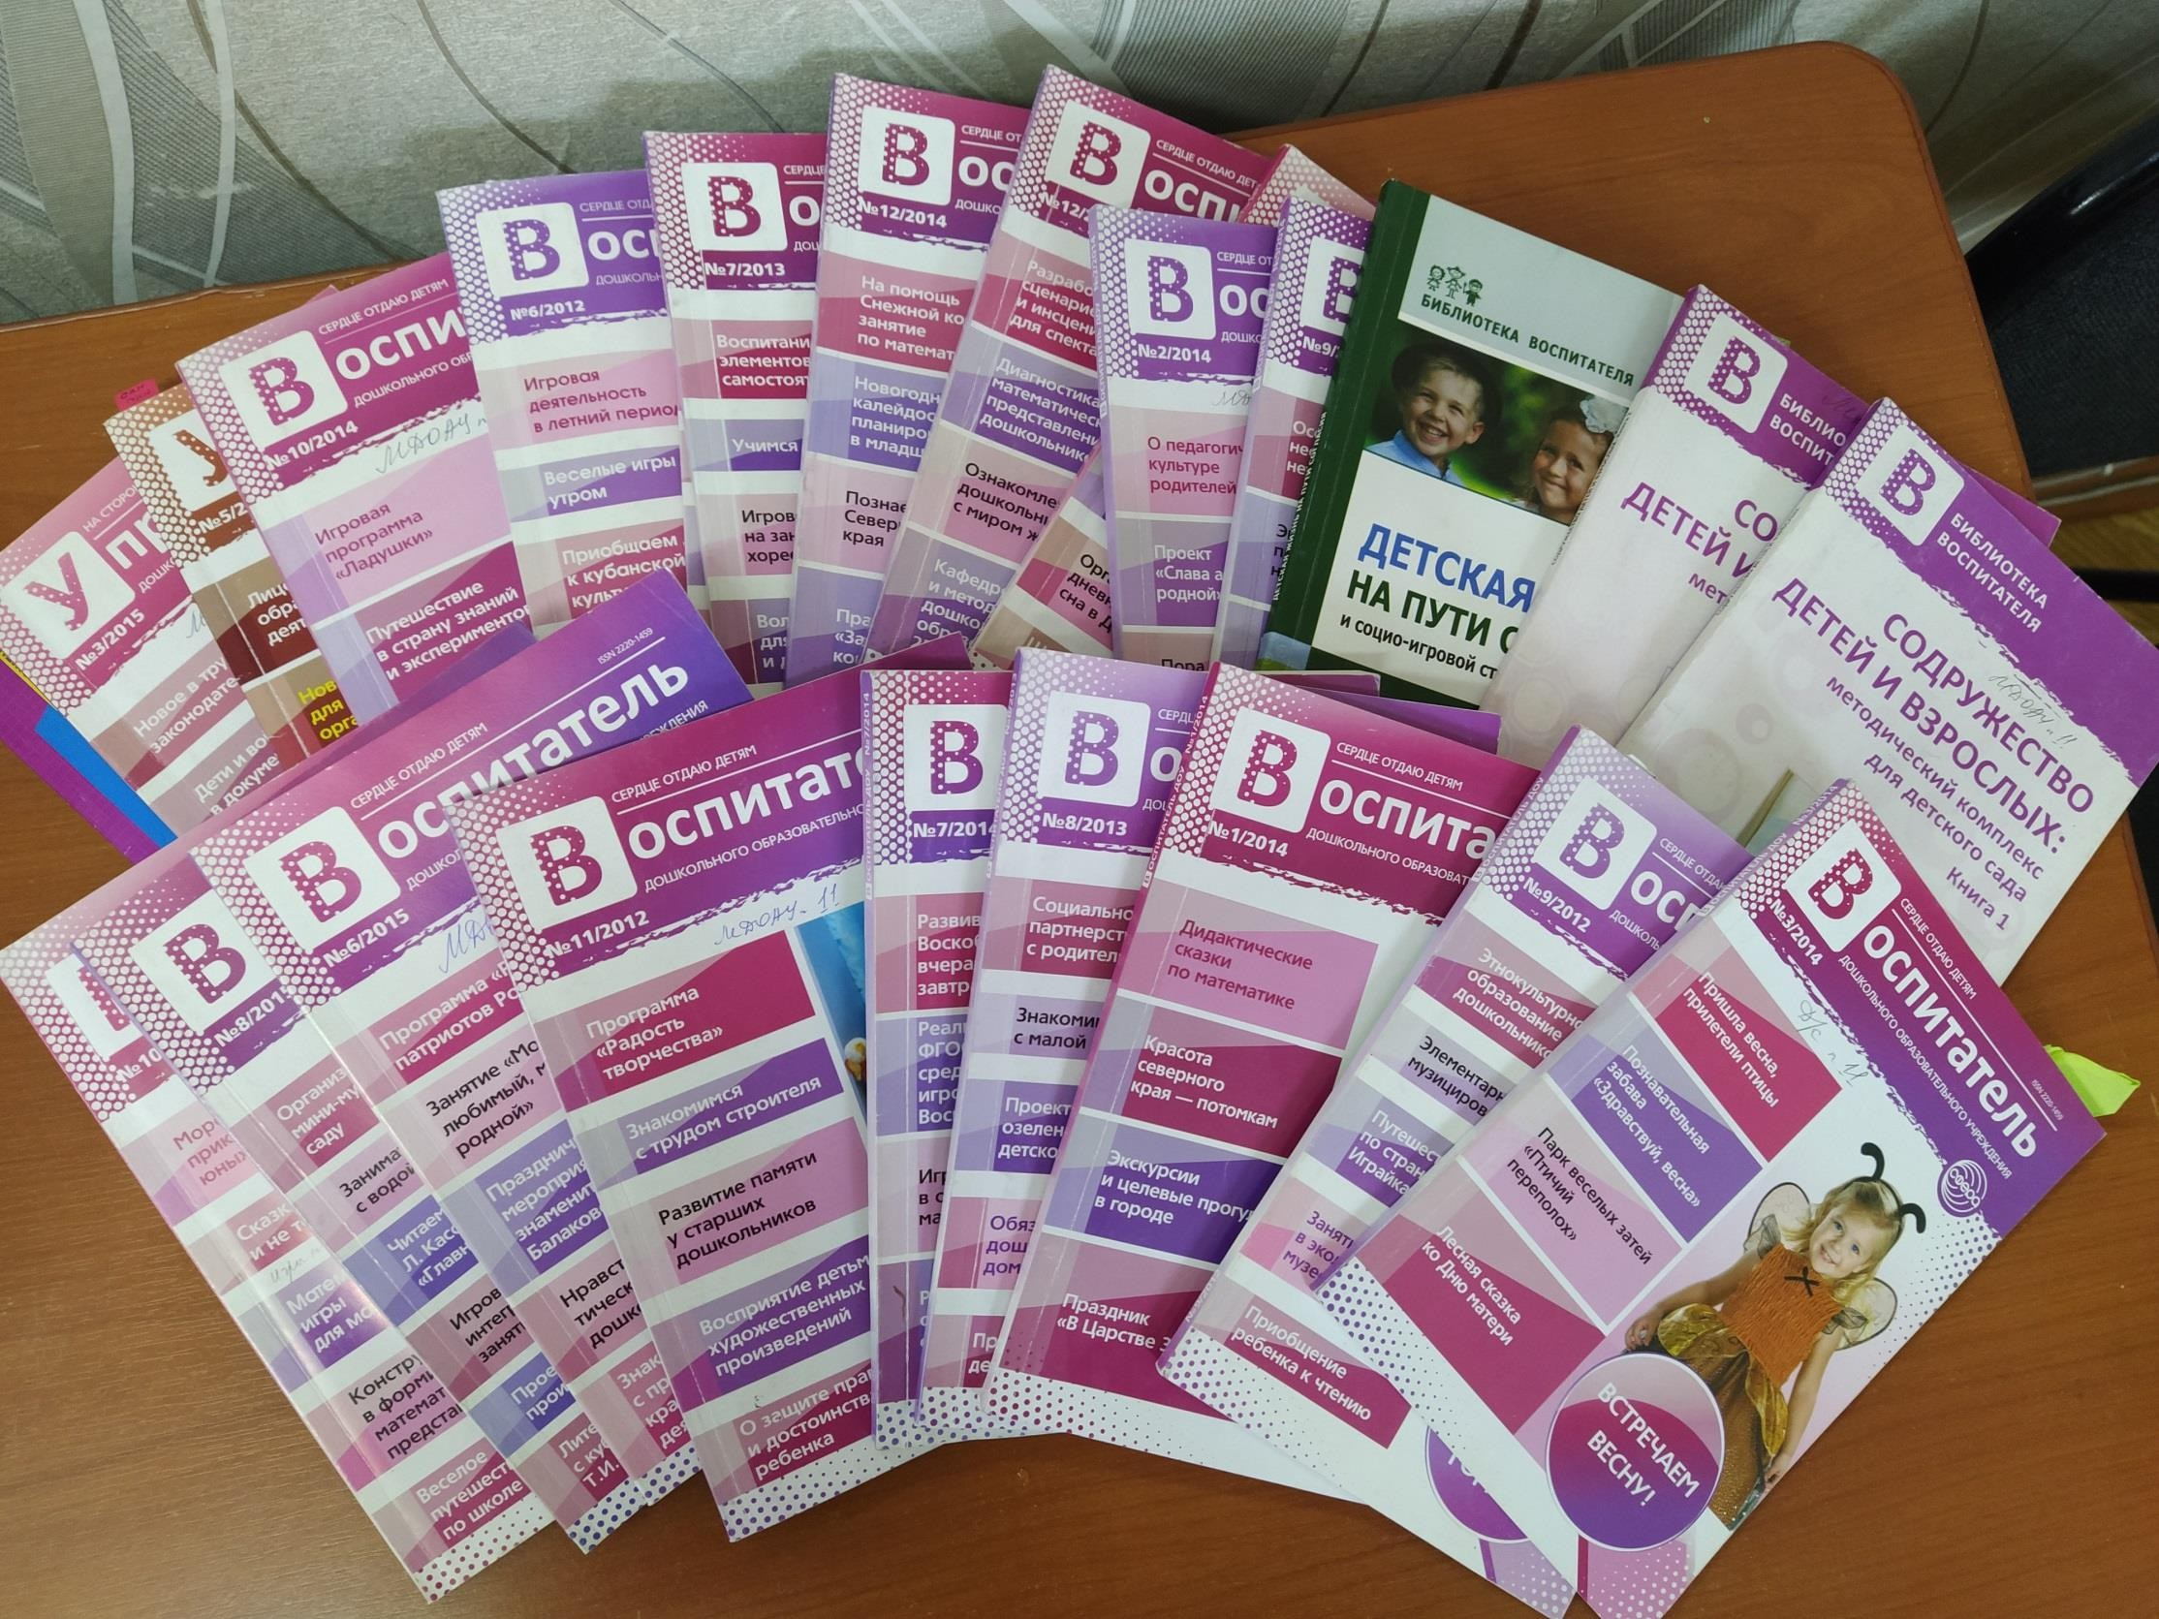

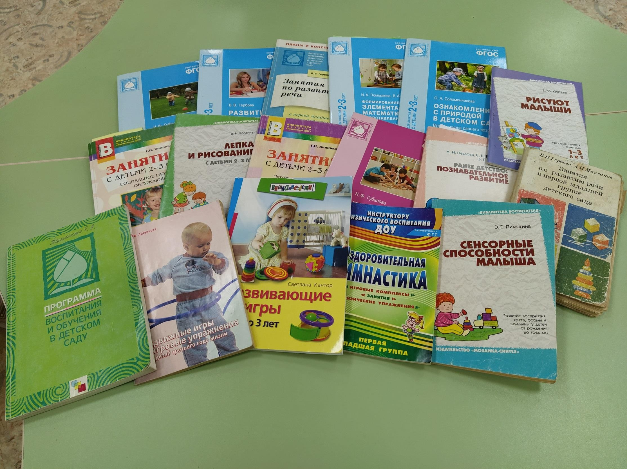



Only two pages were converted.
Please Sign Up to convert the full document.

www.freepdfconvert.com/membership

